

# GALAXY CAPACITIVE LEVEL ELECTRODE

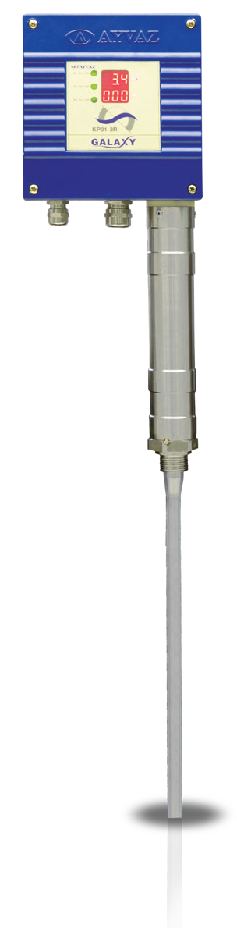

KP-01

GENERAL FEATURES

Ayvaz KP-01 Capacitive Level Controller works according to capacitance measurement principle. It is used to display continuous levels in conductive and non-conductive liquids. KP-01 comprises a level transmitter which is integrated into the electrode that produces a standard analog signal of 4-20mA. Analog output of 4-20mA can be monitored from the display located on the panel protection box. KP-01's display both 4-20mA analog output and liquid level as percentage in tank or the boiler. A specially designed and winglet- fit cooling pipe is used for heat insulation of the electrode.

Capacitance measurement principle is used to indicate the level. Electrode rod and vessel wall form a capacitor. It is basically based on the fact that the value of a capacity is affected by dielectric value of the substance between the plates and from the plate areas, as well as from the distance between them.As the area of the electrode and tank wall is fixed, the only variable thing is the substance inside the tank which plays a dielectric role.

rev.0119

If the level of such dielectric substance changes, the current running through the plates would change proportionately, as well. A dielectric is defined as an insulating substance which keeps many liquids such as water outside.

Dielectric constant of air and vacuum is 1 while it is bigger than 1 for other substances and therefore, capacity changes in line with the change in amount of the substance inside the tank. In order to obtain a useful result of measurement, measuring rod (dip stick) dipped at various depths into liquids must be insulated entirely. After zero point measuring range is adjusted, level can be read through the display unit.

|  |  |
| --- | --- |
| PRODUCT FEATURES | |
| Body | AISI 316 Ti |
| Elec. Box | Aluminium |
| Flange | Forged Steel |
| Electrode | AISI 316 Ti |
| Electrode Insulation | PTFE |
| Connection | 3/4" BSP / DN32-50  PN40 Flanged |
| Intermediate Disc | PTFE |
| Max. Working Temp. | 238°C |
| Max. Working Pressure | 32 Bar |
| Thermal Fuse | 115°C |
| Supply | 230 V (Opt. 115V, 24V)+  %10, 50-60 Hz |
| Power Consumption | 5 VA |
| Precision | Degree 1: Water >  0.5 μS |
| Degree 2: Water >0.20  Μs |
| Degree 3: Fuel oil or 2,3 |
| Output | 4-20 mA Analog and Proportional |
| Protection Class | IP44 |

**Application Areas**

* Steam Boilers
* Supply Tanks
* Concrete Tank
* Plastic Tanks
* Chemical Industry
* Food Industry
* Marine
* Pharmautical Industry

**Working Principle:**

To define electrical capacity, we assume that two conductive plates are used;



Insulation

Due to leakage currents and the distance (d) between tank and probe is relatively high, above equation is not practical to use. Therefore, instead of electrical capacity, impedance measurement will provide accurate level results.



Capacity

Impedance

Distance Distance

Impedance is Z = R + jL + ( jC )-1. R is defined as reel component and represents the medium conductivity.

jLw is the second component and defined as inductive reactance. This component is ignored. Hence, the chance of extra error due to electrostatic measuring is removed. Findal impedance formula becomes as follow Z= R + (jC ) -1. The capacitive level measurement we manufacture works on the transfer of electrical charges principle.

Total impedance is defined as Z=V / I. I (Current) I=Q / t

Q (Coulomb) t (sn)

(jC )-1 is the capacitive reactance we want to measure. So, electrical charges and impedance are on the same phases. In brief, electrical charges flowed into medium are directly proportional with capacitive reactance.

For coaxial sensor;

a= Radius of electrod

b= Radius of insulated electrod L= Length

Impedance can be defined as follows:



Excitation applied between 10KHz.250KHz based on length for all our models. ( == 2 x p x f) Linearity error that may be caused by conductivity component (R) effect is prevented by electronic circuit design and mechanical design. Reduced to a level lower than 1ppm, acceptable as zero.

TECHNICAL SPECIFICATION - THREADED

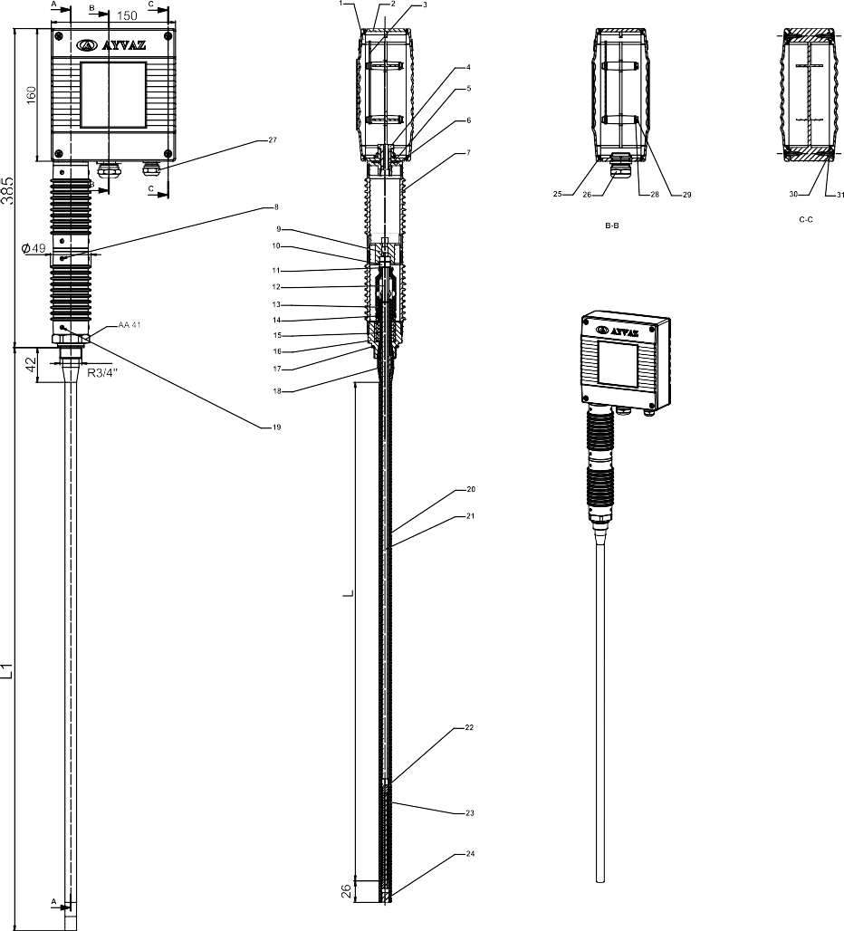

**Cut View**

**Cut View**

**Cut View**

|  |  |
| --- | --- |
| L (mm) | L1 (mm) |
| 300 | 373 |
| 400 | 477 |
| 500 | 583 |
| 600 | 688 |
| 700 | 794 |
| 800 | 899 |
| 900 | 1004 |
| 1000 | 1110 |
| 1100 | 1214 |
| 1200 | 1319 |
| 1300 | 1423 |
| 1400 | 1528 |
| 1500 | 1636 |
| 2000 | 2156 |

|  |  |  |
| --- | --- | --- |
| Part No / Name | | Material |
| ı | Cover | Aluminium |
| 2 | Board Body | Aluminium |
| 3 | Control Board Circuit | Stripboard |
| 4 | Board Connection Bolt | 8.8 |
| 5 | Bolt Gasket | Lastik |
| 6 | Heat Insulation Pipe Cover | Castermid |
| 7 | Heat Insulation Pipe | Aluminium |
| 8 | Rivet |  |
| 9 | Heat Insulation Pipe Connec. | Castermid |
| 10 | A.K.B. Nut |  |
| 11 | Washer |  |
| 12 | Electrode Fixing Bolt | AISI 316 |
| 13 | Electrode Fixing | Peek |
| 14 | Spring Pressure Bear | AISI 304 |
| 15 | Electrode Pressure Spring | AISI 302 |
| 16 | Electrode Body | AISI 316Ti |
| 17 | Electrode Body Gasket | AISI 304 |
| 18 | Fixing Part | AISI 316 |
| 19 | Rivet | Ǿ2x4 |
| 20 | PFA Insulation | PFA |
| 21 | Electrode Pipe | AISI 316Ti |
| 22 | Wire Cover | Teflon |
| 23 | Wire | Weld Wire |
| 24 | Stopper | PFA |
| 25 | Board Cover Gasket | Silicon |
| 26 | Raccord |  |
| 27 | Raccord |  |
| 28 | Washer |  |
| 29 | Cylindrical Head Bolt |  |
| 30 | Gasket |  |
| 31 | Countersunk Bolt |  |



4

TECHNICAL SPECIFICATION - FLANGED

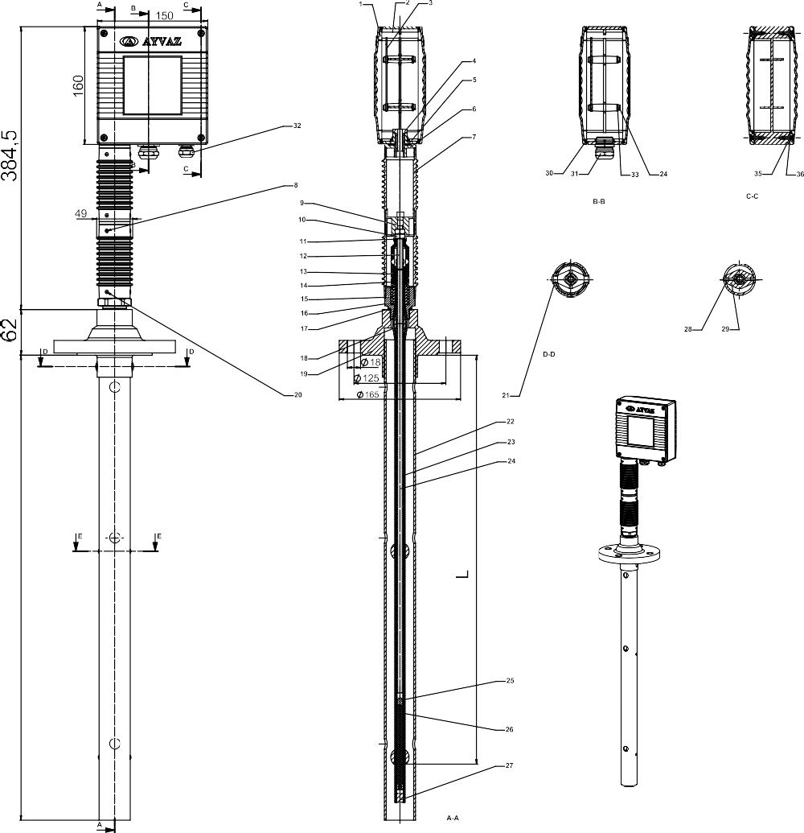

**Cut View**

**Cut View**

**Cut View**

**Cut View**

**Cut View**

|  |  |
| --- | --- |
| L (mm) | L1 (mm) |
| 275 | 316 |
| 375 | 420 |
| 475 | 526 |
| 575 | 631 |
| 675 | 737 |
| 775 | 842 |
| 875 | 947 |
| 975 | 1053 |
| 1075 | 1157 |
| 1175 | 1262 |
| 1275 | 1366 |
| 1375 | 1471 |
| 1475 | 1579 |
| 1975 | 2099 |

|  |  |  |
| --- | --- | --- |
| Part No / Name | | Material |
| ı | Cover | Aluminium |
| 2 | Board Body | Aluminium |
| 3 | Control Panel Circuit | Stripboard |
| 4 | Panel Connector Bolt | 8.8 |
| 5 | Pano Bağlantı Cıvata Contası | Lastik |
| 6 | Isı Yalıtım Borusu Kapağı | Castermid |
| 7 | Heat Isolation Pipe | Alüminyum |
| 8 | Perçin |  |
| 9 | Isı Yalıtım Borusu Ara Parça | Castermid |
| 10 | A.K.B. Nut |  |
| 11 | Washer |  |
| 12 | Elektrod Sabitleme Cıvatası | AISI 316 |
| 13 | Elektrod Sezgi Sabitleyicisi | Peek |
| 14 | Yay Baskı Yatağı | AISI 304 |
| 15 | Elektrod Baskı Yayı | AISI 302 |
| 16 | Elektrod Gövdesi | AISI 316Ti |
| 17 | Elektrod Gövde Contası | AISI 304 |
| 18 | Sabitleme Parçası | AISI 316 |
| 19 | FLANŞ DN50 PN40 | C 22,8 |
| 20 | Perçin |  |
| 21 | Perçin |  |
| 22 | Muhafaza Borusu | AISI 304 |
| 23 | PFA Kılıf | PFA |
| 24 | Elektrod Sezgi Çubuğu | AISI 316Ti |
| 25 | Tel kılıfı | Teflon |
| 26 | Wire | Weld Wire |
| 27 | Tapa | PFA |
| 28 | Perçin |  |
| 29 | Merkezleme Parçası | PFA |
| 30 | Pano Kapak Contası | Silicon |
| 31 | Raccord |  |
| 32 | Raccord |  |
| 33 | Washer |  |
| 34 | Silindirik Başlı Cıvata |  |
| 35 | Gasket |  |
| 36 | Havşa Başlı Cıvata |  |

3D APPLICATION SAMPLE

Steam Line

Safety Valve

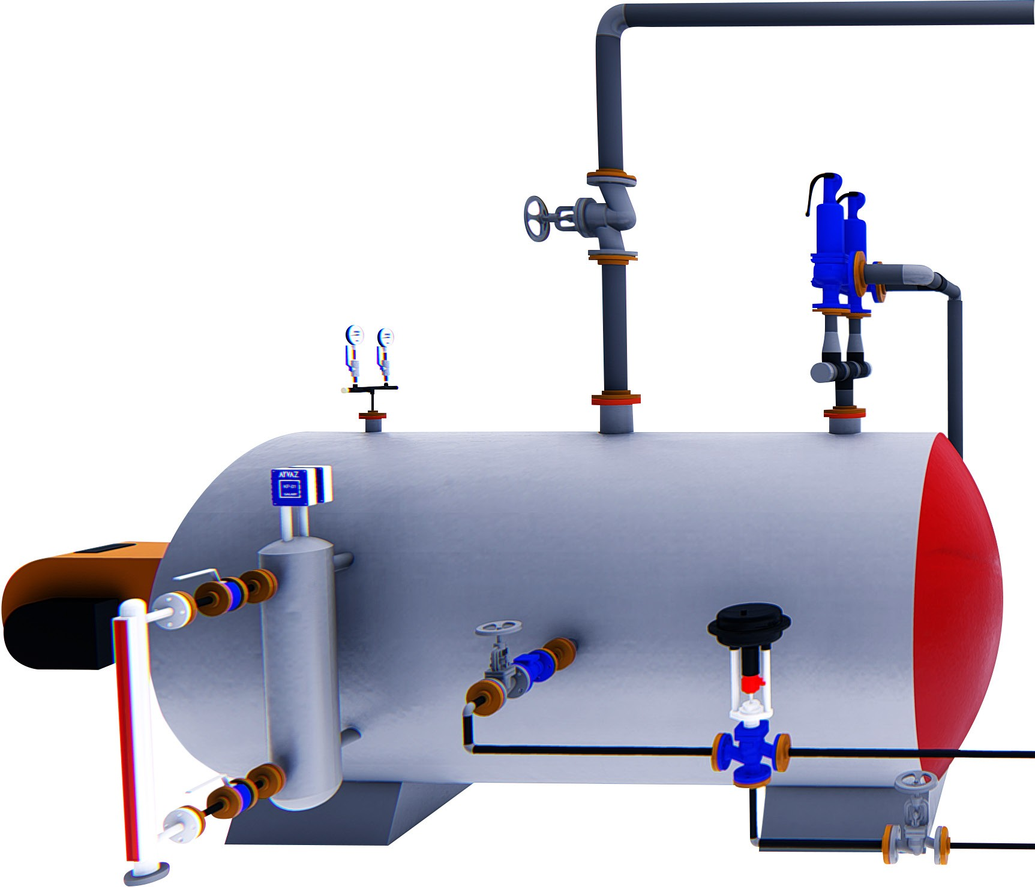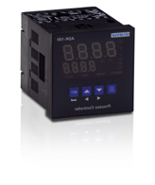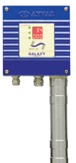

Globe Valve

2018 - Non contractual document - Reproduction forbidden without prior authorization

Manometer

KP-01

ADK-100

Steam Boiler

MGK-33 Monoblock

Valve

Check Valve

3 Ways Motorized Valve

Electrical Connection Scheme

For electrical connection, minimum

1.5 mm2 multi-core cable should be

used.

Fuel Tank

Drainage



KP-01

# GALAXY CAPACITIVE LEVEL ELECTRODE

**HEAD OFFICE - FACTORY**



Atatürk Sanayi Bölgesi Hadımköy Mahallesi Mustafa İnan Caddesi No: 44 Arnavutköy - İSTANBUL Tel: +90 212 771 01 45 (pbx) | Fax: +90 212 771 47 27

[info@ayvaz.com](mailto:info@ayvaz.com) | [www.ayvaz.com](http://www.ayvaz.com/)